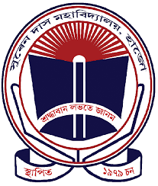
DEPARTMENT OF BOTANY
SUREN DAS COLLEGE, HAJO
ACADEMIC CALENDER (2020-2021)
Date(s) | Event/Activity/Target
30-09-2020 | UG admission process to be completed by this date
2 Nov, 2020 | Commencement of UG 1st Semester (CBCS) and UG 5th Semester (Non-CBCS) offline classes as per Gauhati University COVID guidelines.
Nov, 2020 | Distribution of Time Tables for current semesters  Distribution of CO/PO/PSO to the students
Nov, 2020 | Orientation cum Fresher’s program for the new comers  Bridge classes for the new comers  Online workshop for 1st semester students of the college for ICT training
Dec, 2020 | Career counseling session for 5th Semester students  College week  Class Tests/Assignments  Departmental Seminar (To be presented by students)
Jan, 2021 (10th -17th) | Winter and Magh Bihu Break
March, 2021 | Educational field trip  Commencement of UG 1st and 5th semester sessional examination
March, 2021 | The Faculty Academic Exchange Programme in collaboration with the Department of Botany, Nowgong Girls’ College
April, 2021 | Class Tests/Assignments  Departmental Seminar (To be presented by students)
April, 2021 (14th -16th) | Bohag Bihu Holidays
April, 2021 | Result Compilation and Discussion
May, 2021 | Class Tests/Assignments  Departmental Seminar (To be presented by students)
5th June, 2021 | “Plant a tree competition” for students on Worlds Environmental Day
June, 2021 | Commencement of UG 1st and 5th semester End Term examination (Tentative)
July, 2021 | Commencement of UG 6th semester classes (online)

