Field Trip and Field Report Submission
Dept. of History
2022
Paper `Oral History and Oral Tradition` Code: HIS-SE-4014 is a compulsory paper of Skill Enhancement Course for BA 4th Semester students. A field trip was arranged on 14/06/22 at Hajo Koibortotola Village to collect the existing oral tradition in the village. On the basis of the field trip, students had submitted their field reports to the Department and accordingly marks to each and every students had been assigned.

Name and Roll Numbers of the Students went for Field Trip
Sl. No | Student Name | Class Roll No
1 | Abinash Sarma | 20BA0001
2 | jitul konwar | 20BA0002
3 | Moidan Ali | 20BA0003
4 | Jeherul Islam | 20BA0005
5 | MISS JESMIN CHOUDHURY | 20BA0006
6 | ANOWAR HUSSAIN | 20BA0008
7 | RAFIQUL ISLAM | 20BA0010
8 | MAHIDUL ALI | 20BA0011
9 | MANASHI KALITA | 20BA0012
10 | TRISHNA DEVI | 20BA0013
11 | SANIWARA BEGUM | 20BA0015
12 | DIPANDITA MAHANTA | 20BA0016
13 | JAYASHRI DEKA | 20BA0017
14 | Silima Parbin | 20BA0018
15 | nabanita deka | 20BA0023
16 | PAMPI DEKA | 20BA0024
17 | FARIJUL HAQUE | 20BA0027
18 | SUMI RANI DAS | 20BA0028
19 | NABANIKA MALAKAR | 20BA0030
20 | BANTI DAS | 20BA0031
21 | DEIJEE MAHANTA | 20BA0033
22 | NAZMINA KHATUN | 20BA0036
23 | BIKI BARUAH | 20BA0037
24 | ARJIDA AKHTARA | 20BA0039
25 | JINTI MANI DAS | 20BA0040
26 | JAHANARA PARBIN | 20BA0041
27 | RABIUL ISLAM | 20BA0042
28 | ABDUL HANNAN | 20BA0044
29 | RABINA AHMED | 20BA0045
30 | SAURAV MAJUMDAR | 20BA0046
31 | SAIDUR RAHMAN | 20BA0047
32 | REBA BAKHTIAR | 20BA0048
33 | BANJIR BEGUM | 20BA0049
34 | SIRAJUL KHAN | 20BA0050
35 | BIREN BHARALI | 20BA0051
36 | CHAKINA KHATUN | 20BA0053
37 | MASTAFIZUR RAHMAN | 20BA0054
38 | REKHA RANI DAS | 20BA0056
39 | AMINUR RAHMAN | 20BA0058
40 | MURSIDA BEGUM | 20BA0060
41 | NITA KUMARI | 20BA0061
42 | ARJUMA BEGUM | 20BA0063
43 | NURJAMAL ALI | 20BA0064
44 | MAINA KHATUN | 20BA0067
45 | MOMINA KHATUN | 20BA0068
46 | KIRTI KAMAL DAS | 20BA0069
47 | SUMAN DAS | 20BA0070
48 | Rafiqul islam | 20BA0071
49 | RITA MANI MALAKAR | 20BA0072
50 | MAHIBAR RAHMAN | 20BA0073
51 | JINTI MONI DEKA | 20BA0077
52 | JYOTIRMOY DEKA | 20BA0078
53 | Sikha Kalita | 20BA0079
54 | JERIFA OHEDA | 20BA0084
55 | INA ARA BEGUM | 20BA0086
56 | GOBINDA DAS | 20BA0093
57 | Kazim ali | 20BA0097
58 | NASIRUDDIN AHMED | 20BA0101
59 | DOLI SHARMA | 20BA0102
60 | RIMPI KALITA | 20BA0104
61 | KARABI KUMARI | 20BA0106
62 | JURI DEKA | 20BA0108
63 | SAMUDRA MALAKAR | 20BA0109
64 | ASHMINA BEGUM | 20BA0110
65 | LATIKA DAS | 20BA0112
66 | JONALI BEGUM | 20BA0113
67 | ASHIQUR RAHMAN | 20BA0114
68 | MAMUNI BEGUM | 20BA0115
69 | CHANDAN BEZBARUAH | 20BA0116
70 | PAPU ALI | 20BA0117
71 | MAFIDA BEGUM | 20BA0118
72 | MANJUL HAQUE | 20BA0120
73 | MAJMIN KHANAM | 20BA0123
74 | RABIAL HUSSAIN | 20BA0125
75 | ANOWARA BEGUM | 20BA0127
76 | MANISHA BEGUM | 20BA0128
77 | SEHNAZ SULTANA | 20BA0129
78 | USMITA THAKURIA | 20BA0131
79 | MOUSUMI BEGUM | 20BA0134
80 | HAFIZ RASHIDUL ALOM | 20BA0135
81 | PARIMALA BEGUM | 20BA0137
82 | HALIMA BEGUM | 20BA0138
83 | NURJAHAN PARBIN | 20BA0139
84 | Aparna Deka | 20BA0140
85 | SAHIDA PARBIN | 20BA0143
86 | YASMINUL CHOUDHURY | 20BA0144
87 | PARISHMITA DAS | 20BA0145
88 | AMINA PARBIN | 20BA0146
89 | BARNALI KALITA | 20BA0147
90 | RESMINA BEGUM | 20BA0150
91 | HALIDA PARBIN | 20BA0151
92 | NURJAHAN BEGUM | 20BA0156
93 | JUNUKA BEGUM | 20BA0157
94 | HALIMA BEGUM | 20BA0158
95 | RAKIBUL HUSSAIN | 20BA0160
96 | KABEL ALI | 20BA0161
97 | TRISHNA MALAKAR | 20BA0162
98 | Brajen Kalita | 20BA0163
99 | ASIQUR RAHMAN | 20BA0164
100 | TAFIKUR RAHMAN | 20BA0165
101 | AKHTER HUSSAIN | 20BA0167
102 | DOLI DEKA | 20BA0168
103 | RAJASHREE DAS | 20BA0170
104 | ANUSHMITA MEDHI | 20BA0171
105 | MAUSAMI BEGUM | 20BA0172
106 | MANOJ KUMAR | 20BA0175
107 | DIMPI BARUAH | 20BA0176
108 | PAMPI BEGOM | 20BA0177
109 | BARASHA KALITA | 20BA0178
110 | NUR ISLAM | 20BA0179
111 | NARJINA BEGUM | 20BA0181
112 | DIPUL ALI | 20BA0183
113 | JYOTIKA DAS | 20BA0187
114 | ROUSANARA BEGUM | 20BA0188
115 | RAIFUL HAQUE | 20BA0189
116 | Atikur Rahman | 20BA0192
117 | NAYANMANI DAS | 20BA0195
118 | JUMIARA BEGUM | 20BA0196
119 | Miftaur Zaman | 20BA0199
120 | PAPARI BEGUM | 20BA0202
121 | BEAUTY BEGUM | 20BA0203
122 | NITUL DAS | 20BA0204
123 | JEUTI DAS | 20BA0206
124 | AJAY MALAKAR | 20BA0211
125 | MANASHJYOTI KALITA | 20BA0212
126 | AMISHA BEGUM | 20BA0215
127 | ATIKUR RAHMAN | 20BA0218
128 | JAHANGIR HUSSAIN | 20BA0224
129 | REJAUL HAQUE | 20BA0225
130 | MAINUL HAQUE | 20BA0228
131 | AMANUR RAHMAN | 20BA0237
132 | ABDUL RAHIM | 20BA0239
133 | MOFIDA KHATUN | 20BA0240
134 | JAYASRI MEDHI | 20BA0242
135 | BARAKHA RANI DAS | 20BA0245
136 | RUBI BEGUM | 20BA0246
137 | GAGAN DAS | 20BA0255
138 | BHASKAR DAS | 20BA0256
139 | BANAJIT MALAKAR | 20BA0257
140 | MINOWARA PARBIN | 20BA0260
141 | DHRUBA JYOTI DAS | 20BA0262
142 | ANJUMA PARBIN | 20BA0263
143 | REZMIN SULTANA | 20BA0264
144 | PARBIN SULTANA | 20BA0273
145 | BABUL ALI | 20BA0274
146 | AKASH JYOTI OZA | 20BA0283
147 | TRISHNA BARMAN | 20BA0285
148 | SAMUDRA BARUAH | 20BA0287

Photographs of Field Trip:
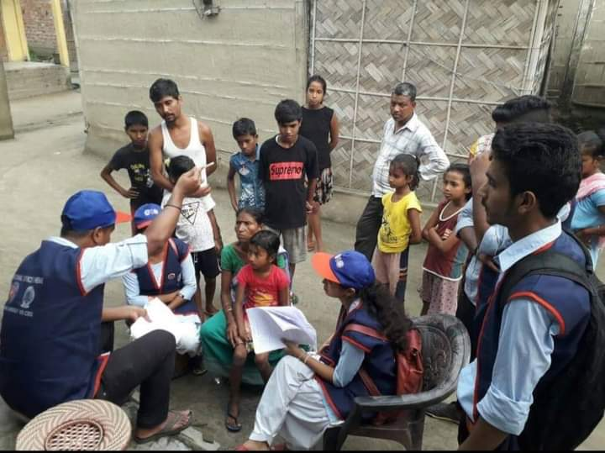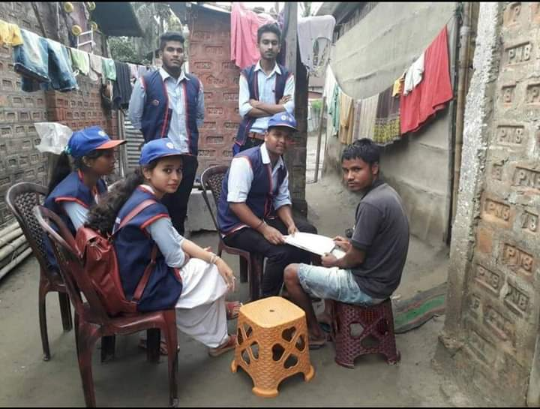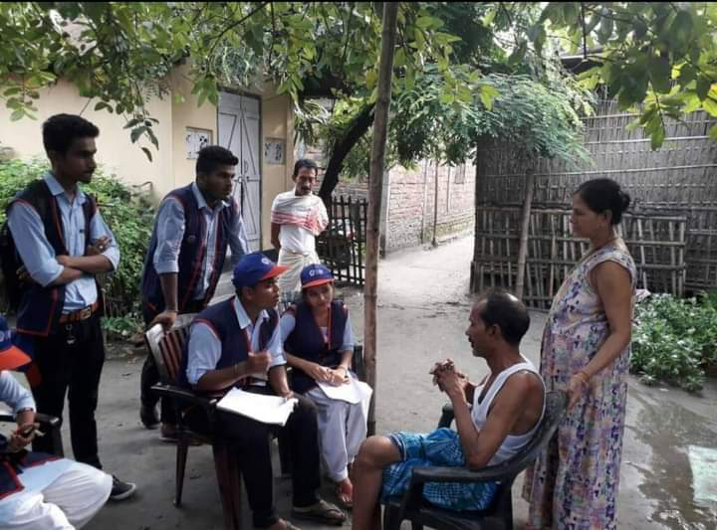

Field Report Submission:
